Assignment - 1

1. Explain the difference between frontend, backend, and full-stack development with
suitable real-world examples.
Ans.:

- Frontend: The part of a website that users see and interact with (the visual interface).
- Backend: The part behind the scenes that handles data, logic, and server operations (the engine).
- Full-stack: A combination of both frontend and backend development skills, allowing a developer to work on all parts of an application.
2. Create a simple diagram showing how the client-server model works in web architecture.
Ans.:
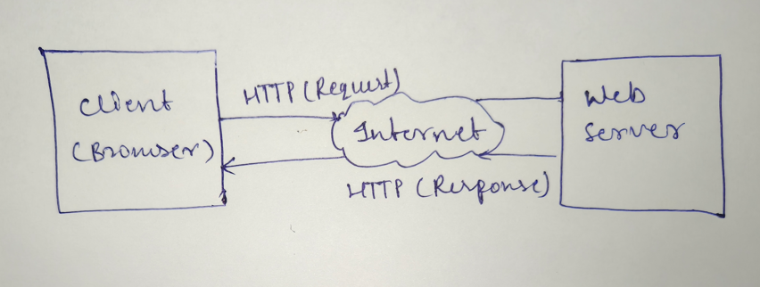

3. Describe how a browser requests and displays a web page from a web server.
Ans.:

- DNS Lookup: The browser contacts a DNS server to translate the human-friendly URL (e.g., www.example.com) into a machine-readable IP address.
- HTTP Request: The browser sends an HTTP request to the server at that IP address, asking for the specific page resources.
- Server Response: The server processes the request and sends back an HTTP response containing the requested files (HTML, CSS, JS).
- Browser Rendering: The browser parses the HTML to build the DOM tree, applies CSS styles, and executes JavaScript to display the final interactive page to the user.

4. Identify and list the tools required to set up a web development environment. Explain the
purpose of each.
Ans.:
- Code Editor (e.g., VS Code): Provides an interface for writing, editing, and managing code files with helpful features like syntax highlighting and extensions.
- Web Browser (e.g., Chrome, Firefox): Used to view and test the web pages you are building.
- Version Control System (e.g., Git): Tracks changes to your codebase over time, allowing for collaboration and easy restoration of previous versions.
- Terminal/Command Line: Allows you to interact with your operating system and run development commands (like starting a server or installing packages).
- Package Manager (e.g., npm, yarn): Manages project dependencies and libraries, making it easy to install and update third-party code packages.
5. Explain what a web server is and give examples of commonly used servers.

Ans.:
A web server is a computer system or software that stores, processes, and delivers web content—such as HTML files, images, and videos—to users via their web browsers. When you enter a website URL, your browser sends a request to a web server, which then fetches the requested files and sends them back to your browser to display.

Commonly used web servers include:
- Apache HTTP Server: An open-source, widely used server known for its flexibility and reliability.
- Nginx: Popular for its high performance, stability, and efficiency in handling concurrent connections.
- Microsoft IIS (Internet Information Services): A web server designed for Windows Server environments.
- Node.js (with Express): While often used as an application runtime, it can also function as a lightweight web server for modern web applications.

6. Define the roles of a frontend developer, backend developer, and database administrator
in a project.
Ans.:
- Frontend Developer: Responsible for the user-facing side of a website or application. They use HTML, CSS, and JavaScript to build the visual interface, ensuring it is responsive, accessible, and provides a great user experience.
- Backend Developer: Manages the "behind-the-scenes" server-side logic. They build and maintain the APIs, server infrastructure, and application logic that powers the website, ensuring data is processed and communicated correctly between the server and the client.
- Database Administrator (DBA): Responsible for the performance, integrity, and security of the database. They design database schemas, manage data backups, ensure quick data retrieval, and maintain database efficiency to support the application's needs.

7. Install VS Code and configure it for HTML, CSS, and JavaScript development. Take a
screenshot of the setup.
Ans.:

HTML :

<!DOCTYPE html>
<html>
<head>
<title>My First Web Page</title>
<link rel="stylesheet" href="style.css">
</head>
<body>
<h1>Welcome to Web Development!</h1>
<button id="clickBtn">Click me!</button>
<script src="script.js"></script>
</body>
</html>

CSS :

body {
font-family: Arial;
text-align: center;
margin-top: 50px;
}
button {
padding: 10px 20px;
background-color: #007bff;
color: white;
border: none;
border-radius: 5px;
}

javaScript :

document.getElementById("clickBtn").addEventListener("click", function() {
alert("Button clicked!");
});

Extensions:

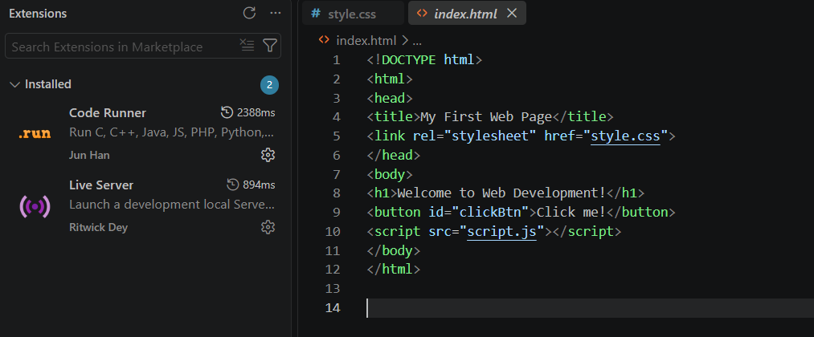

8. Explain the difference between static and dynamic websites. Provide an example of
each.
Ans.:

- Static Websites: These consist of fixed content that is delivered to the user exactly as stored. The content does not change based on user interaction or time unless the developer manually updates the files.
  - Example: A simple personal portfolio site or a resume page.
- Dynamic Websites: These generate content in real-time, often fetching data from a database or server to display personalized or up-to-date information for each user.
  - Example: A social media feed (like Instagram or Twitter) or an e-commerce store (like Amazon).

9. Research and list five web browsers. Explain how rendering engines differ between
them.
Ans.:
Here are five common web browsers and their primary rendering engines:
- Google Chrome: Uses the Blink engine (a fork of WebKit). It is known for its speed and performance.
- Mozilla Firefox: Uses the Gecko engine. It focuses on web standards and privacy.
- Apple Safari: Uses the WebKit engine. It is optimized specifically for Apple's ecosystem.
- Microsoft Edge: Uses the Blink engine (the same as Chrome). It includes Microsoft-specific enhancements for performance and integration.
- Opera: Also uses the Blink engine. It often incorporates unique features and optimizations on top of the base engine.

Rendering engines are the "brains" of the browser; they take the HTML, CSS, and JavaScript files from a website and interpret them to draw the page you see on the screen. Differences arise because each engine may interpret web standards slightly differently, handle performance optimizations in unique ways, or offer specific support for different web technologies. This is why a website might sometimes look or behave slightly differently across different browsers.
10. Draw a labelled diagram showing the basic web architecture flow — client, server,
database, and APIs.
Ans.:
